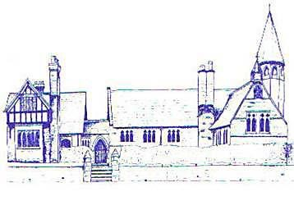
An Early Years Theologist
Age Range | Early Learning Goal | Skills
Reception | Listening, Attention and Understanding | - Listen attentively and respond to what they hear with relevant questions, comments and actions when being read to and during whole class discussions and small group interactions  - Make comments about what they have heard and ask questions to clarify their understanding  - Hold conversation when engaged in back and forth exchanges with their teacher and peers
 | Speaking | - Express their ideas and feelings about their experiences using full sentences, including use of past, present and future tenses and making use of conjunctions, with modelling and support from their teacher
 | People, Culture and Communities | - Know some similarities and differences between different religious and cultural communities in this country, drawing on their experiences and what has been read in class

