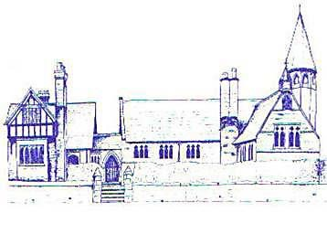
An Early Years Scientist
Age Range | Area of Learning |  | Skills
Reception | Communication and Language |  | - Learn new vocabulary  - Use new vocabulary  - Ask questions to find out more and to check what has been said to them  - Connect one idea to another using connectives  - Articulate their ideas and thoughts in well-formed sentences  - Describe events in some detail  - Use talk to work out problems and organise thinking and activities  - Explain how things work and why they might happen  - Use new vocabulary in different contexts  - Engage in non-fiction books  - Listen to and talk about some non-fiction to develop a deep familiarity with new knowledge and vocabulary
 | Physical Development |  | - Know and talk about the different factors that support their overall health and wellbeing  - Engage in regular physical activity  - Understand healthy eating  - Understand dental hygiene  - Have a good sleep routine
 | Understanding the World |  | - Explore the natural world around them  - Describe what they see, hear and feel while they are outside  - Understand the effect of changing seasons on the natural world around them
Early Learning Goal | Communication and Language | Listening, Attention and Understanding | - Listen attentively and respond to what they hear with relevant questions and comments when being read to and during whole class and small group discussions  - Make comments about what they have heard and ask questions to clarify their understanding
 |  | Speaking | - Offer explanations for why things might happen making use of recently introduced vocabulary
 | Personal, Social and Emotional Development | Managing Self | - Manage their own basic hygiene and personal needs, including dressing, going to the toilet and understanding the importance of healthy food choices
 | Understanding the World | The Natural World | - Explore the natural world around them, making observations and drawing pictures of animals and plants  - Know some similarities and differences between the natural world around them and contrasting situations  - Explore how things work  - Plant seeds and care for growing plants  - Understand the key features of the life cycle of a plant and an animal  - Beging to understand the need to respect and care for the natural environment and all living things  - Talk about the differences between materials and changes they notice

