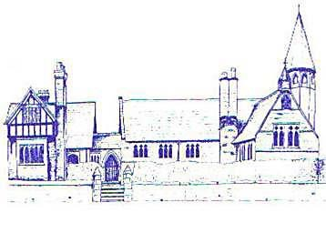
An Early Years Artist
Age Range | Area of Learning |  | Skills
Reception | Expressive Arts and Design |  | - Explore, use and refine a variety of artistic effects to express their ideas and feelings  - Return to and build on their previous learning, refining ideas and developing their ability to represent them  - Create collaboratively, sharing ideas, resources and skills
 | Physical Development |  | - Develop their small motor skills so they can use a range of tools effectively, safely and confidently  - Use their core muscle strength to achieve a good posture when sitting at a table of sitting on the floor  - Develop overall body strength, balance, coordination and agility
Early Learning Goal | Physical Development | Fine Motor Skills | - Hold a pencil effectively in preparation for fluent writing their the tripod grip in almost all cases  - Use a range of small tools, including scissors  - Begin to show accuracy and care when drawing
 | Expressive Arts and Design | Creating with Materials | - Safely use and explore a variety of materials, tools and techniques, experimenting with colour, design, texture, form and function  - Share their creations, explaining the process they have used

