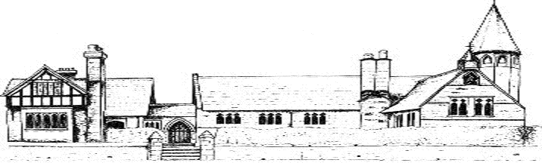

ECCLESTON C.E. PRIMARY SCHOOL
ART AND DESIGN END POINTS AND
KNOWLEDGE

By the end of Year 1, our children will;
Knowledge
Drawing, colour, texture,  Form, printing, pattern | Know that there are a variety of tools used for drawing  Name all the colours  Know that there are a variety of tools that you can apply colour with  Begin to know about the famous artists, craftsmen or designers, such as Wassily Kandinsky  Know how textiles create things  Know that overlapping helps to create effects  Awareness of natural and man-made forms  Develop awareness of patterns  Know that there are different things that you can print with
Skills
Drawing, colour, texture,  Form, printing, pattern | Use a variety of drawings tools and materials  Explore different textures  Observe and draw landscapes  Observe patterns  Use drawing to develop and share ideas, experiences and imagination  Mix colours  Apply colour with a range of tools  Use painting to develop and share ideas, experiences and imagination  Collage  Shape and form from direct observation  Use sculpture to develop and share their ideas, experiences and imagination  Create patterns  Print using fruit/veg  Repeating patterns
Vocabulary
Crayons, pastels, chalks, pencil, pencil crayon, wax crayon, rough, smooth, hard, soft, landscape, stripy, spotty, curvy, wavy, zig zag, primary and secondary colours, names of materials, textiles and fabrics, like, dislike, techniques, patterns, textures, shapes, firm, sculptures

By the end of Year 3, our children will;
Knowledge
Drawing, colour, texture,  Form, printing, pattern | Know the proportions to draw a face accurately  Know pencils can be used in a variety of ways  Understand that colours can be mixed  Know different brushes are used for different purposes  Know a variety of techniques to apply colour  Know about artists, architects and designers, such as Sir Christopher Wren  Know how to weave using a variety of material  Know the effectiveness of different adhesives  Know that work must look aesthetically pleasing  Know there are different types of printing  Know that different types of printing can create different textures/patterns which can be symmetrical or asymmetrical
Skills
Drawing, colour, texture,  Form, printing, pattern | Experiment with the potential of various pencils  Closely observe and draw a range of living and non-living things  Initial sketches as a preparation for painting  Accurate drawings of people – particularly faces  Colour mix  Introduce different types of brushes  Use a variety of techniques- apply colour using dotting, scratching, splashing  Weaving to create a scene  Shape, form, model and construct a range of materials
Vocabulary
As previous years, plus: observation, proportions, colour mixing, dotting, scratching, splashing, symmetry, architect

By the end of Year 5, our children will;
Knowledge
Drawing, colour, texture,  Form, printing, pattern | Know the effect of light on objects from different directions  Understand shade, tint and tone  Know how images can be manipulated using a graphic package  Know about the artist  Understand shape, form  Understand properties of media  Discuss and evaluate the work of other sculptors  Know different methods of printing  Have an understanding of pattern building on previous knowledge  Learn about a range of artists, sculptors and designers
Skills
Drawing, colour, texture,  Form, printing, pattern | Produce increasingly accurate drawings of objects  Explore the use of texture in colour  Use colour for different purposes  Select and use materials  Plan and develop ideas  Model and join  Draw familiar objects with the correct proportions  Experiment with creating mood, feeling and movement  Print on fabrics  Develop skills in the use of clay sculpture
Vocabulary
As previous years, plus: concept, tint, tone, purpose, manipulate, digital image, embellish, media, combining, abstract, purpose, sculptor, sculpture

By the end of Year 6, our children will;
Knowledge
Drawing, colour, texture,  Form, printing, pattern | Understand the concept of perspective  Refine knowledge of the effect of light on objects from different directions and know the effect on people  Understand hue, tint, tone, shades and mood  Know about artists and sculptors, comparing and evaluating their work  Develop understanding of the properties of media  Know different methods of printing.  Have an understanding of pattern building on previous knowledge
Skills
Drawing, colour, texture,  Form, printing, pattern | Compare the texture of different surfaces  Produce increasingly accurate drawings of people including using perspective  Use colour to express feelings  Be able to import an image into a graphics package  Create layered images from original ideas  Refine the skill of embellishing  Refine skills of modelling and joining using appropriate media  Work collaboratively on a larger scale  Improve plans and develop ideas based on experiences from previous years  Discuss and evaluate own work to suggest further improvements  Discuss and evaluate own work  Create pattern for purposes
Vocabulary
As previous years, plus: perspective, mood, expressing feelings, layered image, layering, refine, collaboratively, further improvements, combining, abstract, purpose

