ECCLESTON CE PRIMARY SCHOOL
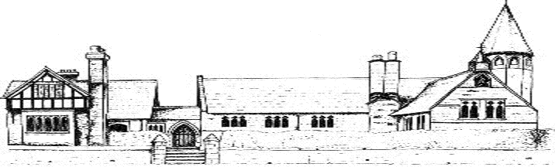

SCIENCE CURRICULUM

CYCLE A
 | Autumn | Spring | Summer
Class 1 | Animals including humans  Seasonal changes | Plants  Seasonal changes | Everyday materials  Seasonal changes
Class 2 | Light and shadow | Forces, magnets and poles | Plants
Class 3 | States of matter Properties and changes of materials | Sound  Forces | Living things and their habitats
Class 4 | Evolution and inheritance -How living things on earth have changed over time * Cross curricular literacy links to writing non-chronological reports on fossils Living Things in their Habitats Animals, including humans | Light | Electricity

CYCLE B
 | Autumn | Spring | Summer
Class 1 | Animals including humans  Seasonal changes | Plants  Seasonal changes | Everyday materials  Seasonal changes
Class 2 | Rocks, fossils and soil | Animals and humans | Living things, habitats and sustainability
Class 3 | Earth and Space | Electricity | Animals including humans
Class 4 | Evolution and inheritance -How living things on earth have changed over time * Cross curricular literacy links to writing non-chronological reports on fossils Living Things in their Habitats Animals, including humans | Light | Electricity

