ECCLESTON CE PRIMARY SCHOOL
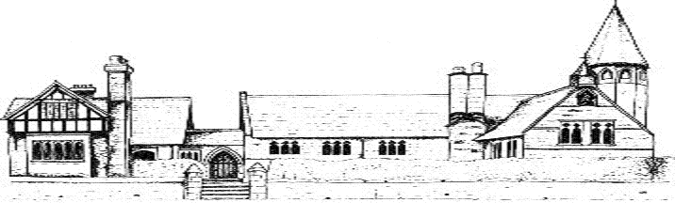
HISTORY CURRICULUM
CYCLE A
 | Autumn | Spring | Summer
Class 1 | Changes within living memory – looking at how children’s lives have changed and that of their immediate family | Lives of significant individuals-famous people who have shaped British history e.g. Andy Warhol, British monarchs, Mary Anning etc. (Linked to class topic) | Significant historical events, places and changes in the local area e.g. how schools or farming methods have changed over time
Class 2 | Changes in living memory -Toys | Lives of significant individuals – inventors Alexander Graham Bell | History of Chester – including The Roman Empire and its impact, events, people and places in our locality
Class 3 | Ancient Greece | Study of an aspect or theme in British history | The Viking and Anglo-Saxon struggle for the Kingdom of England, including Britain’s settlements by Anglo-Saxons and Scots
Class 4 | Ernest Shackleton | How World War 2 changed aspects of life in Great Britain | The Mayans

CYCLE B
 | Autumn | Spring | Summer
Class 1 | Changes within living memory – looking at how children’s lives have changed and that of their immediate family | Lives of significant individuals-famous people who have shaped British history e.g. Andy Warhol, British monarchs, Mary Anning etc. (Linked to class topic) | Significant historical events, places and changes in the local area e.g. how schools or farming methods have changed over time
Class 2 | Lives of significant individuals | Explorers, e.g. Neil Armstrong, Darwin, Cook, Columbus | Events in history beyond living memory (Great Fire)
Class 3 | Changes in Britain from the Stone Age to the Iron Age | Study of an aspect or theme in British history (famous mountain expeditions) | Ancient Egypt
Class 4 | Ernest Shackleton | How World War 2 changed aspects of life in Great Britain | The Mayans

