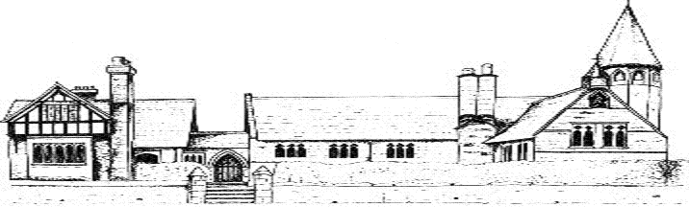

ECCLESTON CE PRIMARY SCHOOL
Let Your Light Shine
PSHE Curriculum Statement
At Eccleston CE Primary School, we are united in our vision to prepare our children for life in the modern world. We will do this by instilling a lifelong love of learning and embedding Christian values that reflect the example Jesus has set. We strive for excellence in all we do, enabling all members of our school to flourish.
“Let your light shine”-Matthew 5.16

PHSE AT ECCLESTON CE PRIMARY SCHOOL
Intent
Our principle aim, in the teaching of PHSE, is to equip our children with the knowledge, skills and attributes they need to keep themselves healthy, safe and prepared for life in the modern world.
In line with current legislation, we cover the three core themes of PHSE, Health and Well Being, Relations and Living in the Wider World. In line with out vision statement, we aim to create lifelong learners with the confidence and ability to develop skills and understanding when encountering new experiences, new challenges and new situations. We strive for a caring, nurutuirng environment where every child is recognised, celebrated and encouraged to develop their true potential and to flourish. We aim to encourage mutual respect, responsibility and self-esteem in a happy, safe environment full of Christian values.
Implementation
The Jigsaw and Kidsafe programmes are the basis of our PHSE curriculum. Through these, our children develop the knowledge and skills they need to manage their lives and to thrive whilst at Eccleston CE Primary School and beyond. Jigsaw is implemented throughout the whole school worship/assembly sessions and regular lessons and Kidsafe is presented once a term. We also have an Emotional Literacy Support Assistant who will run individual or group sessions with appropriate pupils.
Through these quality programmes, we provide our children with;
- Accurate and relevant knowledge
- Opportunities to create personal understanding
- Opportunities to explore and challenge a range of values, attitudes, beliefs, rights and responsibilities
- A range of skills and strategies to live a healthy, safe, fulfilling, responsible and balanced life
Jigsaw tackles diverse beliefs, values and attitudes that individuals and societies hold. It helps pupils to develop themselves, their understanding of the world and their ability to communicate their feelings positively. Our children also acquire an understanding and experiences of British Values to enable them to feel confident and informed as a British citizen. We also promote our six Christian Values of Thankfulness, Joy & Celebration, Love, Forgiveness, Trust and Friendship throughout the school year.
We celebrate Mental Health Day each year and provide our children with a range of strategies to manage their mental health.
Impact
Our PHSE curriculum ensures that our children have healthy, safe and happy lives. We believe that we enhance children’s education and to help them become caring, respectful, aspirational and confident individuals.
PHSE in the Early Years
PHSE sits within the areas of personal, social and emotional development and understanding of the world. Children at Eccleston CE Primary School quickly learn to develop respectful communication and they are encouraged to be aware of the feelings and wishes of others. Continuous provision is planned to provide the children with opportunities to develop skills taught in Jigsaw, circle time and Kidsafe sessions and then to use them independently. Our youngest children are also exposed to and participate in upholding both British Values and our Christian Values.

