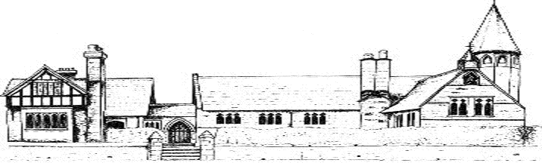
Eccleston C E Primary School
British Values as part of SMSC at Eccleston
Subject | Rule of Law | Tolerance | Liberty | Democracy | Respect
Literacy | Spelling, punctuation and grammar rules | Working together – paired/team work  Listening and responding to others | Reading – freedom to make own book choices  General literacy skills | Persuasion writing – points of view | Turn-taking  Peer-assessment
Maths | Following rules to complete calculations | Working together – paired/team work  Listening carefully to the ideas of others | Enterprise week  Money | Enterprise week | Turn-taking
Science | Understand the importance of safety rules when working scientifically.  Know that there are consequences if rules are not followed. | Scientific discoveries have come from other cultures.  Religious beliefs often compete with scientific understanding. | Make choices when planning an investigation. Others may have different points of view as to where to start. | Take the views and opinions of others into account.  Take turns and instructions from others. | Work as a team.  Discuss findings.  Offer support and advice to others.
RE | Sacred books  Respect the value of rule of law, where all people are equal before the law | World religion day  Ethos of inclusivity and tolerance, where views, race, cultures and beliefs are valued | Balance of individual liberty and the greater good | Eccleston values  All pupils have an equal right to be heard and democracy is modelled in the classroom | World religion day  Visitors from other cultures  Acts of worship  Children are respectful and celebrate the diversity of different cultures, faiths and beliefs
Geography | Grid reference rules | Working together – paired/team work | Knowledge of the world allows choices for work and travel | All pupils have an equal right to be heard  Democracy in the classroom  Eco reps | Respecting the natural power of the Earth, (e.g. floods, earthquakes, volcanoes, tsunamis)
History | Historical laws in UK and other countries, learning about consequences of actions and how laws have evolved over time | Learning how historical groups of people have had to learn to tolerate others in order to live side-by-side | Black History Month | Black History Month  Learning about the origins of democracy in various cultures | Black History Month
Computing | Health and safety  E:safety | Listen and respond appropriately |  | Yr6 working with Rec/Yr1 buddies | Turn-taking
D&T | Health and safety | Listening and responding to others |  |  | Turn-taking
PSHE | E:safety  Anti-bullying week | Anti-bullying week | Anti-bullying week | Anti-bullying week | Anti-bullying week
MFL | Verbs  Grammar rules | Listening and responding to others | Freedom to live/work in other countries more easily with the skill of a second language | All pupils have a right to be heard | Respect for people from other countries and cultures
PE | Rules for games |  | Healthy living
General | School rules |  |  | Junior safety officers  Buddies  School council  School play  Pupil voice | Visits from local Police Constable, Fire Brigade

