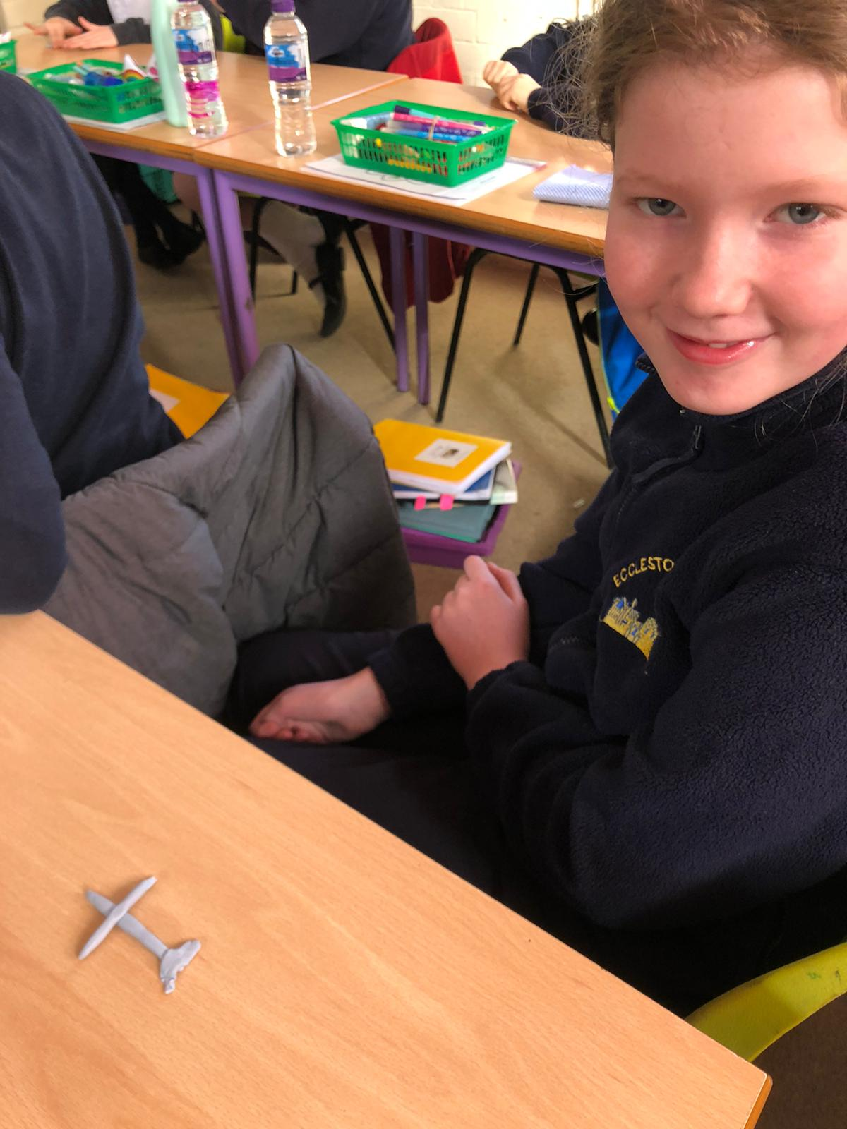

Making crosses and hearts out of playdough during our Easter worship. As we made our crosses, we reflected on the events of Good Friday.

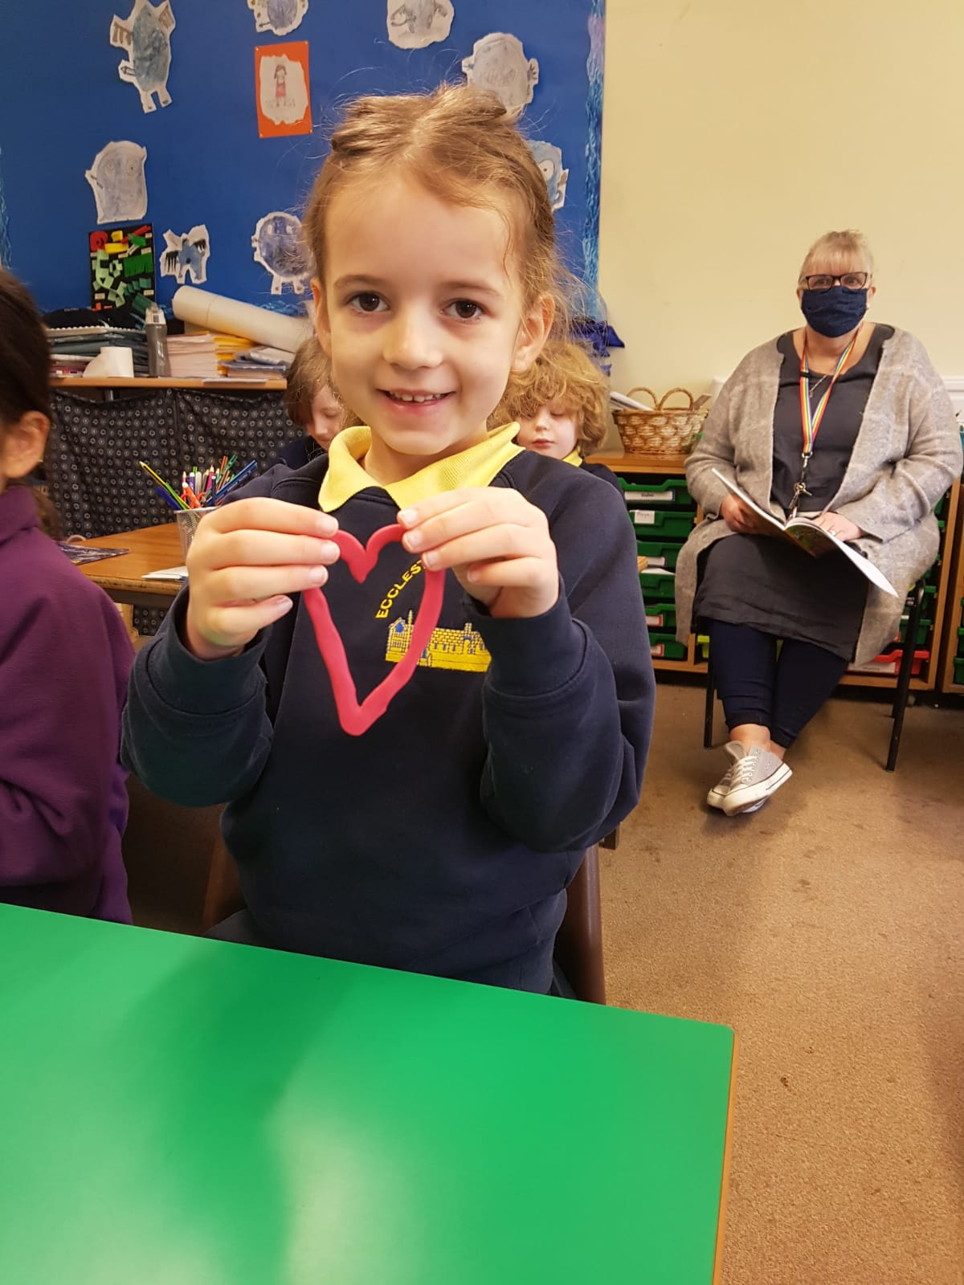

**As we made our hearts, we reflected on the love that Jesus showed to us at Easter and how joyous we are that he rose again on Easter Sunday.**

