TOTAL SPORTS PREMIUM FUNDING: £8,445
Aims | Cost | Objective | Evidence of Impact
To provide high quality sports coaches for all children from Nursery to Y6 in order to improve skills in all aspects of physical education; to develop staff skills and expertise by working alongside coaches as lessons are delivered; for staff to participate in extra-curriculuar training sessions; to increase the amount of competitive sports on offer and to provide more opportunities for children to compete with pupils from different schools, and at a wider range of venues. | £8,500 (approx) | Improve staff knowledge, skills and confidence in planning, delivering and assessing PE  Develop children’s skills in a range of different sports  Increase awareness of healthy diet and healthy lifestyles.  Increase motivation of children to get involved in sport.  Encourage children to lead sporting activities. | All staff report that they feel more confident and skilled in delivering targeted areas of PE. This is confirmed by lesson observations, learning walks and pupil voice surveys which all judge PE lessons to be good, with many aspects outstanding.  A higher percentage of pupils are taking part in after-school sports clubs, including weekend clubs such as cross-country.
TOTAL: | £8,500
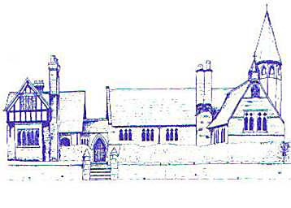

Sports Premium
The Department for Education, Health and Culture, Media and Sport provides funding of £150 million per annum to improve provision of physical education (PE) and sport in primary schools. This funding is ring fenced and can therefore only be spent on provision of PE and sports in schools. Please see below for details as to how this money is spent at Eccleston CE Primary School.

