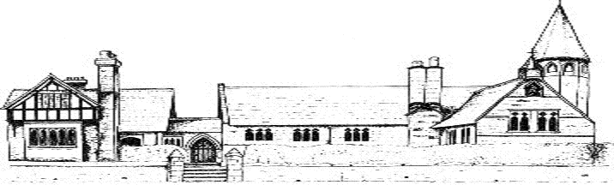

ECCLESTON C.E. PRIMARY SCHOOL
MUSIC END POINTS AND KNOWLEDGE

By the end of Year 1, our children will;
Knowledge
Know a range of traditional songs, rhymes, chants and hymns
Begin to understand the importance of correct breathing when singing
Begin to understand the importance of enunciation when singing
Understand there is a wide range of music to explore and enjoy
Be able to name some instruments of the orchestra and other ensembles
Skills
Be able to sing a range of traditional songs, rhymes, chants and hymns
Begin to use expression when singing
Be able to dance, clap, march etc. in time to the pulse of the music
Use a range of simple percussion effectively
Have performed for each other, to the rest of the school, to parents and to the church congregation
Have had the opportunity to join Performing Arts Club
Vocabulary
loud, quiet, fast, slow, pulse, percussion, rhythm, instrument, note, song, lyrics, echo, breath, conductor

By the end of Year 3, our children will;
Knowledge
Begin to read musical notation and understand the terms treble clef, stave, bar, crochet, minim, semibreve and quaver
Understand the meanings of the terms p and f
Understand the importance of and be able to use good enunciation when singing
Have studied four significant pieces of music and be able to place them in a musical time line (Night on a Bare Mountain, Ride of the Valkyries, Theme from Dr Who and Mambo from West Side Story) and have created their own compositions based on these
Have an understanding of how an orchestra is made up and have listened to a range of orchestral pieces which focus on the various families
Skills
Understand and use the correct posture for singing
Have extended their repertoire for singing and performed more complex songs including rounds
Be able to play the notes c,b,a and g on the recorder
Be able to play a selection of simple songs on the recorder
Be able to begin to improvise and compose on the recorder as well as a range of tuned and untuned percussion
Begin to use phrasing in singing
Vocabulary
woodwind, strings, brass, melody, ostinato, composer, singer songwriter, diminuendo, crescendo, tempo, pitch, treble clef, stave, bar, crochet, minim, semibreve, quaver, orchestra
By the end of Year 5 our children will;
Knowledge
Be able to read musical notation with increasing accuracy fluency and confidence
Understand and respond to the musical terms ff and pp
Be able to improvise musical motifs and melodies on the recorder and on tuned percussion
Have studied and appraised four significant pieces of music in terms of genre, historical context, structure and mood (Beethoven’s 5th Symphony, The Enigma Variations, Mars from the Planets and Connect It by Anna Meredith)
Composed and performed their own pieces around these
Skills
Be able to play the recorder with increasing accuracy, fluency and confidence
Be able to create and perform simple ostinatos and incorporate these into their own composition and performances
Have extended their repertoire for singing including singing in two part harmony
Have performed as part of the ‘Amasing’ mass choir at the Storyhouse Theatre in Chester
Vocabulary
notation, pianissimo (p,pp) pentatonic, dynamics, jazz, pop, sforzando (f,ff,) classical, rock and roll, time signature, bar, texture, timbre, improvise

By the end of Year 6, our children will;
Knowledge
Confidently read musical notation in the treble clef
Understand the pentatonic scale and how to improvise around it on tuned percussion and on the recorder
Understand and respond to the musical terms >, <, diminuendo and crescendo
Have had experience of listening to and appraising a wide range of musical genres
Have an understanding of a musical timeline
Have studied three significant pieces of music in terms of genre, structure and mood (Rhapsody in Blue, A New Year Carol and Carmina Burana)
Composed and performed their own pieces based on these
Skills
Play the recorder with confidence, both in solo and ensemble contexts with increasing accuracy, fluency, control and expression
Sing in solo and ensemble context with increasing accuracy, fluency, control, expression and enunciation
Have had the opportunity to engage in instrumental tuition through Music for Life
Vocabulary
rallentando, presto, twang, rondo, major, minor

