ECCLESTON CE PRIMARY SCHOOL
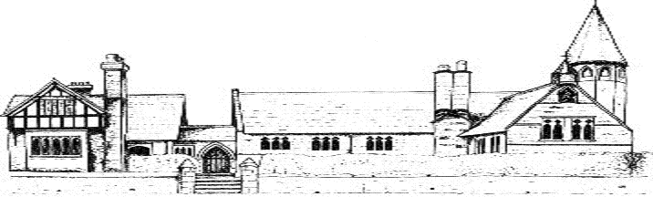

MUSIC CURRICULUM
CYCLE A
 | Autumn |  | Spring |  | Summer
Rabbit Class  (Reception and Year 1) | Hey You!  Charanga Unit  Traditional songs and rhymes | Singing skills  Christmas Performance | Everyone!  Charanga Unit  Wild Man by Kate Bush | Our World  Charanga Unit  Traditional songs and rhymes | Big Bear Funk  Charanga Unit | The Extraordinary Gardener
Squirrel Class  (Years 2 and 3) | Hands, Feet, Heart  Charanga Unit  With A Little Help From My Friends – Lennon and McCartney  Recorders and reading music | Recorders and reading music  Singing skills  Jai Ho by AR Rahman  Christmas Performance | Recorders and reading music  Stop! Charanga Unit  Bolero by Ravel | Three Little Birds Charanga  Unit  Hound Dog by Elvis Presley  Recorders and reading music | I Wanna Play In A Band  Charanga Unit  Ride of the Valkyries by Wagner  Recorders and reading music | Recorders and reading music  Night Ferry by Anna Clyne  Recorders and reading music
Badger Class  (Years 4 and 5) | Mama Mia Charanga Unit  Enigma Variations by Elgar  Recorders and reading music | Recorders and reading music  Singing skills  Le Freak by Chic  Christmas Performance | Recorders and reading music  Amasing preparation  I Got You by James Brown | Recorders and reading music  Composition on recorders | Classroom Jazz 1  Charanga Unit  Tropical Bird by the Trinidad Steel Band  Recorders and reading music  Amasing Performance at the Storyhouse in Chester | Livin On A Prayer  Charanga Unit  Inkanyezi Nezazi by Ladysmith Black Mambazo  Recorders and reading music
Fox Class  (Years 6) | Happy  Charanga Unit  Recorders and reading music  Composition on recorders  Libertango by Piazzolla | Recorders and reading music  Singing skills  Connect It by Anna Meredith  Christmas  Performance | A New Year Carol  Charanga Unit  World War 2 Songs  Schindler’s List soundtrack  Recorders and reading music | Recorders and reading music  Composition  Say My Name by Destiny’s Child | Punk and New Wave  Mazurkas Opus 24 by Chopin  Carmina Burana by Carl Orff  Recorders and reading music | The Beatles  Year 6 musical  Recorders and reading music

CYCLE B
 | Autumn |  | Spring |  | Summer
Rabbit Class  (Reception and Year 1) | Me!  Charanga Unit  Traditional rhymes and songs  Recorders and reading music | Singing skills  Christmas Performance  The Nutcracker Suite by Prokofiev  Recorders and reading music | Rhythm In The Way We Walk and Banana Rap  Charanga Unit  Runway Blues by Ma Rainey  Recorders and reading music | Round and Round  Charanga Unit  Peter and the Wolf study  Traditional rhymes and songs  Recorders and reading music | In The Groove  Charanga Unit  Traditional rhymes and songs  Recorders and reading music | The Enormous Turnip Performance  Mars by Holst  Recorders and reading music
Squirrel Class  (Years 2 and 3) | Let Your Spirit Fly  Charanga Unit  Theme from Dr Who by Grainger and Derbyshire  Recorders and reading music | Recorders and reading music  Singing skills  Christmas Performance | Recorders and reading music  A Night on the Bare Mountain by Mussorgsky | Fanferra by Sergio Mendes  Poetry to music unit  Recorders and reading music | Recorders and reading music  Beethoven’s 5th Symphony | Reflect, Rewind and Replay Charanga Unit  Wonderwall by Oasis  Recorders and reading music
Badger Class  (Years 4 and 5) | Make You Feel My Love  Charanga Unit  Recorders and reading music | Recorder playing  Reading music  Singing skills  Christmas Performance | Rivers in classical music (Smetna, Strauss, Shostakovich) and composition  Recorders and reading music | Classroom Jazz 2  Charanga Unit  Recorders and reading music | Fresh Prince of Belair  Charanga Unit  Connect It by Anna Meredith  Recorders and reading music | Dancing In The Streets  Charanga Unit  Recorders and reading music
Fox Class  (Year 6) | Happy  Charanga Unit  Recorders and reading music  Composition on recorders  Libertango by Piazzolla | Recorder lessons  Singing skills  Connect It by Anna Meredith  Christmas  Performance | A New Year Carol  Charanga Unit  World War 2 Songs  Schindler’s List soundtrack | Recorders and reading music  Composition  Say My Name by Destiny’s Child | Punk and New Wave  Mazurkas Opus 24 by Chopin  Carmina Burana by Carl Orff | The Beatles  Year 6 musical

