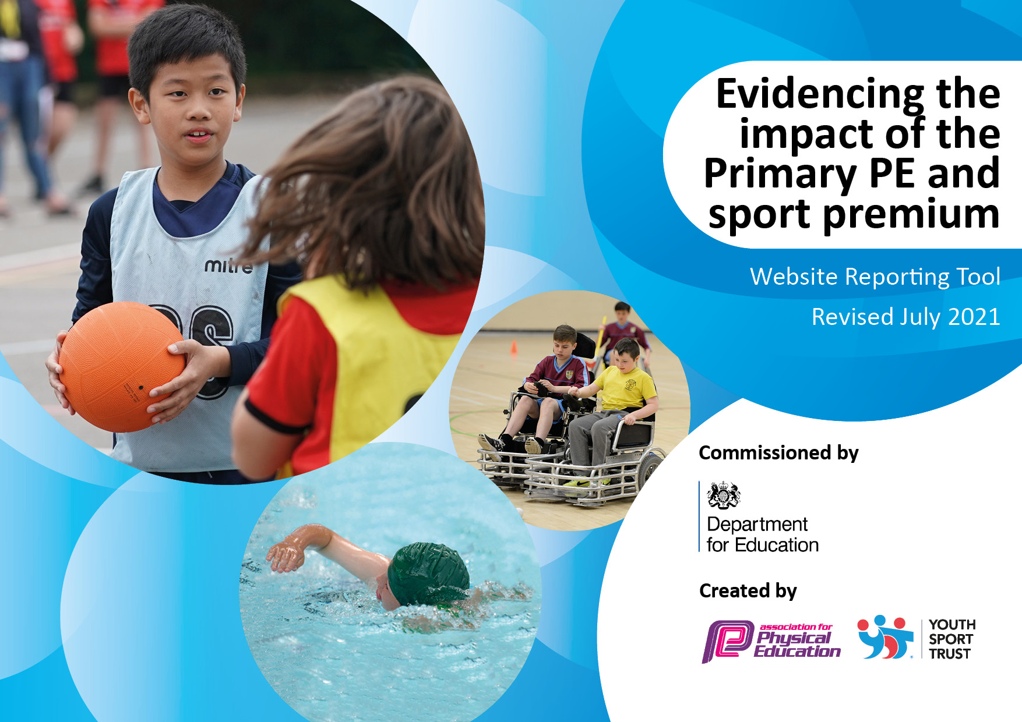
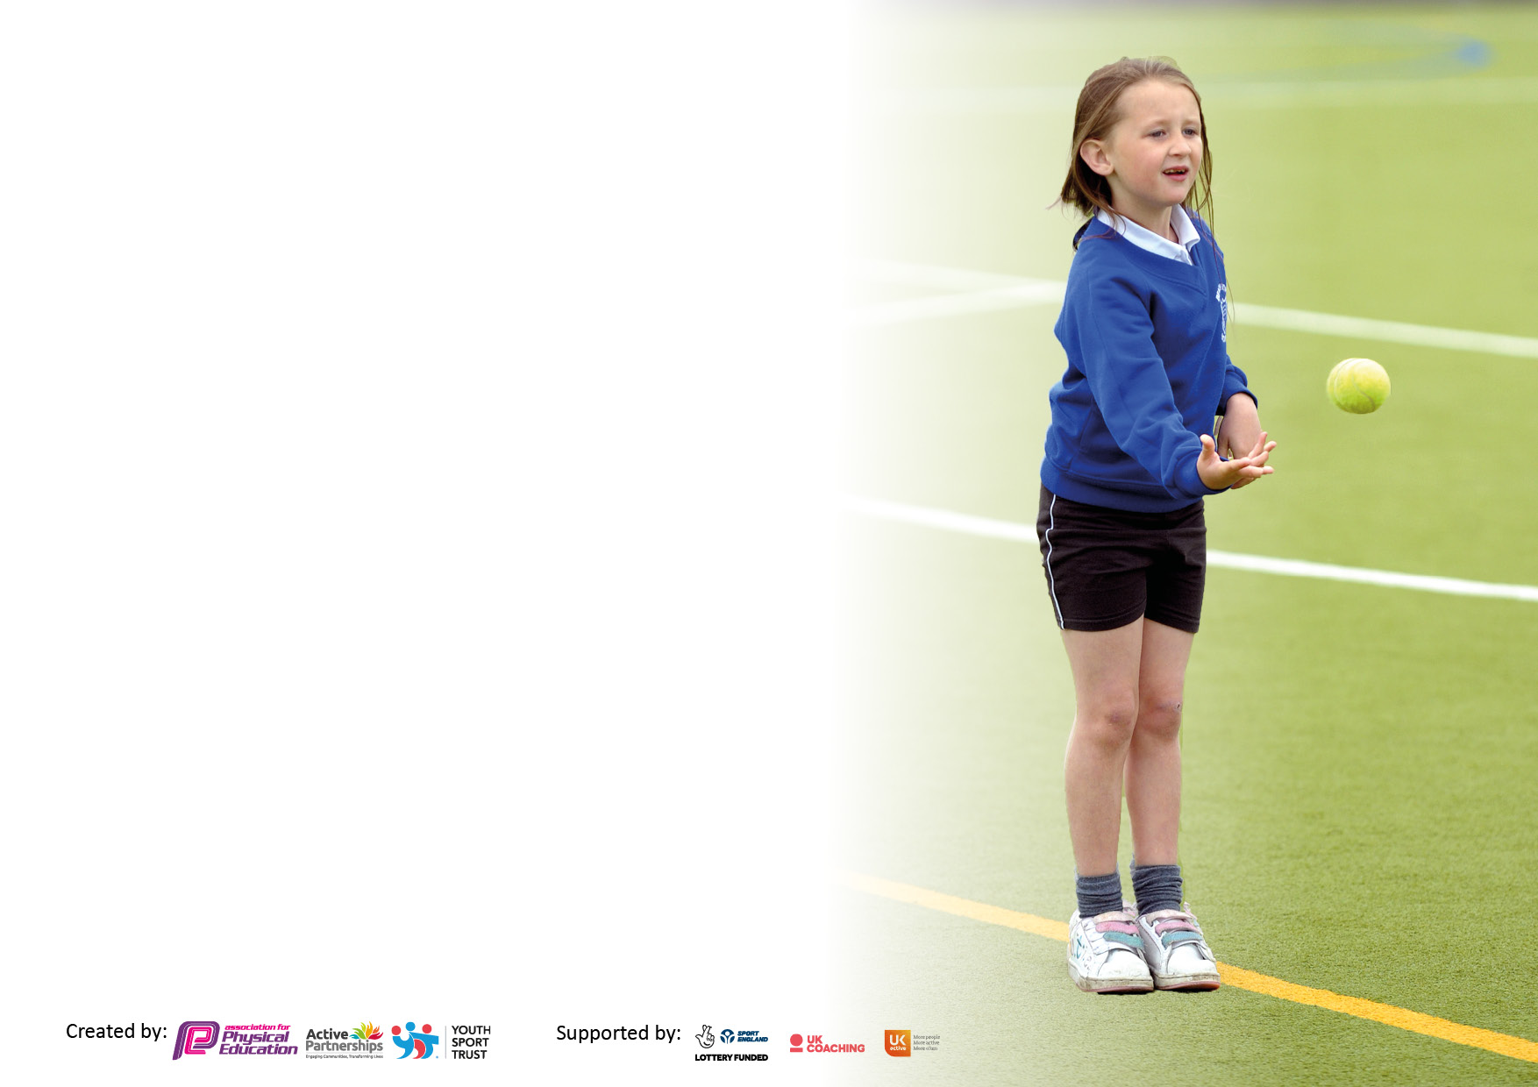

It is important that your grant is used effectively and based on school need. The Education Inspection Framework makes clear there will be a focus on ‘whether leaders and those responsible for governors all understand their respective roles and perform these in a way that enhances the effectiveness of the school’.

Under the Quality of Education Ofsted inspectors consider:
Intent - Curriculum design, coverage and appropriateness
Implementation - Curriculum delivery, Teaching (pedagogy) and Assessment
Impact - Attainment and progress

To assist schools with common transferable language this template has been developed to utilise the same three headings which should make your plans easily transferable between working documents.

Schools must use the funding to make additional and sustainable improvements to the quality of Physical Education, School Sport and Physical Activity (PESSPA) they offer. This means that you should use the Primary PE and sport premium to:

- Develop or add to the PESSPA activities that your school already offer
- Build capacity and capability within the school to ensure that improvements made now will benefit pupils joining the school in future years
- The Primary PE and sport premium should not be used to fund capital spend projects; the school’s budget should fund these.

Pleasevisitgov.ukfortherevisedDfEguidanceincludingthe5keyindicatorsacrosswhichschoolsshoulddemonstrate animprovement.Thisdocumentwillhelpyoutoreviewyourprovisionandtoreportyourspend.DfEencouragesschools to use this template as an effective way of meeting the reporting requirements of the Primary PE and sport premium.

We recommend you start by reflecting on the impact of current provision and reviewing the previous spend.

Schools are required to publish details of how they spend this funding, including any under-spend from 2019/2020, as well as on the impact it has on pupils’ PE and sport participation and attainment. All funding must be spent by 31st July 2022.

We recommend regularly updating the table and publishing it on your website throughout the year. This evidences your ongoing self-evaluation of how you are using the funding to secure maximum, sustainable impact. Final copy must be posted on your website by the end of the academic year and no later than the 31st July 2021. To see an example of how to complete the table please click HERE.

Details with regard to funding
Please complete the table below.

Total amount carried over from 2019/20 | £0
Total amount allocated for 2020/21 | £16,960
How much (if any) do you intend to carry over from this total fund into 2021/22? | £0
Total amount allocated for 2021/22 | £16,960
Total amount of funding for 2021/22. To be spent and reported on by 31st July 2022. | £16,960
Swimming Data
Please report on your Swimming Data below.

Meeting national curriculum requirements for swimming and water safety.

N.B. Complete this section to your best ability. For example you might have practised safe self-rescue techniques on dry land which you can then transfer to the pool when school swimming restarts.
Due to exceptional circumstances priority should be given to ensuring that pupils can perform safe self rescue even if they do not fully meet the first two requirements of the NC programme of study
What percentage of your current Year 6 cohort swim competently, confidently and proficiently over a distance of at least 25 metres?  N.B. Even though your pupils may swim in another year please report on their attainment on leaving primary school at the end of the summer term 2020.  Please see note above | 100%
What percentage of your current Year 6 cohort use a range of strokes effectively [for example, front crawl, backstroke and breaststroke]?  Please see note above | 81%
What percentage of your current Year 6 cohort perform safe self-rescue in different water-based situations? | 81%
Schools can choose to use the Primary PE and sport premium to provide additional provision for swimming but this must be for activity over and above the national curriculum requirements. Have you used it in this way? | No

Action Plan and Budget Tracking
Capture your intended annual spend against the 5 key indicators. Clarify the success criteria and evidence of impact that you intend to measure to evaluate for pupils today and for the future.

Academic Year: 2020/21 | Total fund allocated: £16,960 | Date Updated: April 2022
Key indicator 1: The engagement of all pupils in regular physical activity – Chief Medical Officers guidelines recommend that primary school pupils undertake at least 30 minutes of physical activity a day in school |  |  |  | Percentage of total allocation:
 |  |  |  | %8
Intent | Implementation |  | Impact
Your school focus should be clear what you want the pupils to know and be able to do and about  what they need to learn and to  consolidate through practice: | Make sure your actions to achieve are linked to your intentions: | Funding allocated: | Evidence of impact: what do pupils now know and what can they now do? What has changed?: | Sustainability and suggested next steps:
The questionnaire completed at the start of the year showed that children were less active during lockdown and their basic skills had not developed as fast. To help with this, we have taken the decision to provide playground equipment to encourage children to be active, thus further developing these skills.  Premier to provide two lunchtime sports clubs per week. | Playground active equipment has been provided such as tennis balls, rackets, footballs, playground balls, skipping ropes and throwing and catching activities | £2,550 | Playground observations show an increase in how active children are at playtime and how much access they have to equipment.  Premier clubs are extremely well attended at lunchtime.
Key indicator 2: The profile of PESSPA being raised across the school as a tool for whole school improvement |  |  |  | Percentage of total allocation:
 |  |  |  | 10%
Intent | Implementation |  | Impact
Your school focus should be clear what you want the pupils to know and be able to do and about  what they need to learn and to  consolidate through practice: | Make sure your actions to achieve are linked to your intentions: | Funding allocated: | Evidence of impact: what do pupils now know and what can they now do? What has changed? | Sustainability and suggested next steps:
 |  | £

Key indicator 3: Increased confidence, knowledge and skills of all staff in teaching PE and sport |  |  |  | Percentage of total allocation:
 |  |  |  | % 80
Intent | Implementation |  | Impact
Your school focus should be clear | Make sure your actions to | Funding | Evidence of impact: what do | Sustainability and suggested
what you want the pupils to know | achieve are linked to your | allocated: | pupils now know and what | next steps:
and be able to do and about | intentions: |  | can they now do? What has
what they need to learn and to |  |  | changed?
consolidate through practice:
To ensure that teachers have access to high quality PE CPD.  To ensure that teachers have access to high quality PE planning that has clear progression between year groups. | Premier Sport will provide weekly CPD for staff in the form of team teaching.  Purchase of access to Premier’s online portal which provides clear and high quality planning for each year group. | £11,870 | Teachers report much improved confidence in the teaching of PE in terms of knowledge and skills. The PE Subject Leader monitors this closely through lesson observations and talking to teachers and to children. Pupils are receiving a high quality, broad and engaging PE curriculum. The Subject Leader also monitors the quality of CPD provided.  All staff report increased levels of confidence in the teaching of PE. The Subject Leader monitors the quality of the planning provided on the portal.
Key indicator 4: Broader experience of a range of sports and activities offered to all pupils |  |  |  | Percentage of total allocation:
 |  |  |  | 10%
Intent | Implementation |  | Impact
Your school focus should be clear | Make sure your actions to | Funding | Evidence of impact: what do | Sustainability and suggested
what you want the pupils to know | achieve are linked to your | allocated: | pupils now know and what | next steps:
and be able to do and about | intentions: |  | can they now do? What has
what they need to learn and to |  |  | changed?:
consolidate through practice:
Additional achievements: Premier to provide three after school clubs, covering most areas of PE and sport. These will be offered at a very low cost to pupils and free to pupils in receipt of the PP grant. | Increased levels of participation in after school sports clubs. | £2,245 | The number of children engaged in after school sports activities is rising slowly after the implications of Covid.

Key indicator 5: Increased participation in competitive sport |  |  |  | Percentage of total allocation:
 |  |  |  | %
Intent | Implementation |  | Impact
Your school focus should be clear | Make sure your actions to | Funding | Evidence of impact: what do | Sustainability and suggested
what you want the pupils to know | achieve are linked to your | allocated: | pupils now know and what | next steps:
and be able to do and about | intentions: |  | can they now do? What has
what they need to learn and to |  |  | changed?:
consolidate through practice:
Inter school football matches to be arranged with local schools. | More children will have the opportunity to participate in competitive sport. | £0

Signed off by
Head Teacher: | Katie Prescott
Date: | April 2022
Subject Leader: | Laura Frank
Date: | April 2022
Governor: | Nayland Southorn
Date: | April 2022

