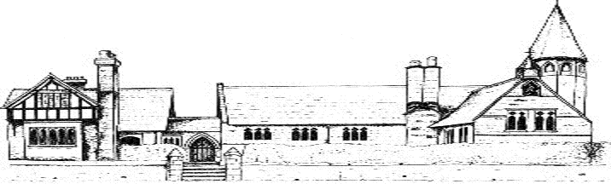
Progression in Reading Skills at Eccleston CE Primary
Year 1
Reading Focus | National Curriculum Objectives
Clarify vocabulary: meaning of words | Discuss word meanings, linking new meanings to those already known
Retrieval | Explain clearly their understanding of what is read to them and recognise and join in with predictable phrases
Sequencing/summarising | Retell key stories, fairy stories and traditional tales and consider their particular characteristics
Inference | Be encouraged to link what they have read or head read to their own experiences  Make inferences on the basis of what is being said and done
Prediction | Predict what might happen on the basis of what has been read so far
Structure and Organisation | Discuss the significance of the title and events
Language Choice | Draw on vocabulary provided by the teacher  Recognise and join in with predictable phrases  Learn to appreciate rhymes and poems, and to recite some by heart
Year 2
Clarify vocabulary: meaning of words | Discuss and clarify the meaning of words, linking new meanings to known vocabulary
Retrieval | Explain and discuss their understanding of books, poems and other material, both those that they list to and those that they read for themselves  Discuss how items of information are related  Answer and ask questions
Sequencing/summarising | Discuss the sequence of events in books and how items of information are related  Retell a wider range of stories, fairy stories and traditional tales
Inference | Make inferences on the basis of what is being said and done
Prediction | Predict what might happen on the basis of what has been read so far
Structure and organisation | Be introduced to non-fiction books that are structured in different ways
Language Choice | Discuss their favourite words and phrases
Year 3
Clarify vocabulary: meaning of words | Explore the meaning of words in context
Retrieval | Ask questions to improve their understanding of a text  Retrieve and record information from non-fiction
Sequencing/summarising | Identify main ideas drawn from more than one paragraph and summarise these
Inference | Draw inferences (inferring characters’ feelings, thoughts and motives from their actions); justify with evidence
Prediction | Predict what might happen from details stated and implied
Structure and organisation | Read books that are structured in different ways  Identify how language, structure and presentation contribute to meaning
Language Choice | Discuss words and phrases that capture the read’s interest and imagination
Year 4
Clarify vocabulary: meaning of words | Explore the meaning of words in context
Retrieval | Ask questions to improve their understanding of a text
Sequencing/summarising | Identify main ideas drawn from more than one paragraph and summarise these
Inference | Draw inferences (inferring characters’ feelings, thoughts and motives from their actions); justify with evidence
Prediction | Predict what might happen from details stated and implied
Structure and organisation | Read books that are structured in different ways  Identify how language, structure and presentation contribute to meaning
Language Choice | Discuss words and phrases that capture the read’s interest and imagination
Year 5
Clarify vocabulary: meaning of words | Explore the meaning of words in context
Retrieval | Ask questions to improve their understanding  Retrieve, record and present information from non-fiction
Sequencing/summarising | Summarise the main ideas drawn from more than one paragraph identifying key details that support the main ideas
Inference | Draw inferences (inferring characters’ feelings, thoughts and motives from their actions); justify with evidence
Prediction | Predict what might happen from details stated and implied
Structure and organisation | Read books that are structured in different ways  Identify how language, structure and presentation contribute to meaning
Language Choice | Discuss and evaluate how authors use language, including figurative language, considering the impact on the reader
Making Comparisons | Make comparisons within and across texts
Year 6
Clarify vocabulary: meaning of words | Explore the meaning of words in context
Retrieval | Ask questions to improve their understanding  Retrieve, record and present information from non-fiction
Sequencing/summarising | Summarise the main ideas drawn from more than one paragraph, identifying key details that support the main ideas
Inference | Draw inferences (inferring characters’ feelings, thoughts and motives from their actions); justify with evidence
Prediction | Predict what might happen from details stated and implied
Structure and organisation | Read books that are structured in different ways  Identify how language, structure and presentation contribute to meaning
Language Choice | Discuss and evaluate how authors use language, including figurative language, considering the impact on the reader
Making Comparisons | Make comparisons within and across texts

