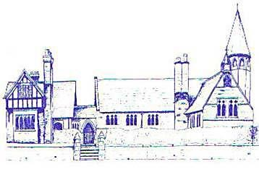
An Early Years Historian
Age Range | Area of Learning |  | Skills
Reception | Communication and Language |  | - Learn new vocabulary  - Use new vocabulary  - Ask questions to find out more and to check what has been said to them  - Connect one idea to another using connectives  - Articulate their ideas and thoughts in well-formed sentences  - Use talk to organise thinking and activities  - Use new vocabulary in different contexts  - Listen to and talk about some non-fiction to develop a deep familiarity with new knowledge and vocabulary
 | Understanding the World |  | - Comment on images of familiar situations in the past  - Compare and contrast characters from stories  - Figures from the past
Early Learning Goal | Communication and Language | Listening, Attention and Understanding | - Listen attentively and respond to what they hear with relevant questions and comment when being read to and during whole class and small group discussions  - Make comments about what they have heard and ask questions to clarify their understanding
 |  | Speaking | - Offer explanations for why things might happen, making use of recently introduced vocabulary
 | Understanding the World | Past and Present | - Talk about the lives of people around them and their rold in society  - Know some similiarities and difference between things in the past and now, drawing on their experiences and what has been read in class  - Understand the past through settings, characters and events read in class and storytelling

