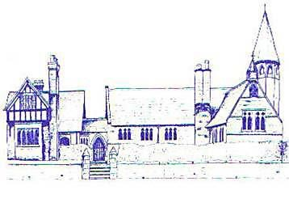
An Early Years Geographer
Age Range | Area of Learning |  | Skills
Reception | Communication and Language |  | - Learn new vocabulary  - Use new vocabulary  - Ask questions to find out more and to check what has been said to them  - Connect one idea to another using connectives  - Articulate their ideas and thoughts in well-formed sentences  - Use talk to organise thinking and activities  - Use new vocabulary in different contexts  - Listen to and talk about some non-fiction to develop a deep familiarity with new knowledge and vocabulary
 | Understanding the World |  | - Draw information from a simple map  - Recognise some similarities and differences between life in this country and life in other countries  - Explore the natural world around them  - Recognise some environments that are different to the one in which they live
Early Learning Goal | Communication and Language | Listening, Attention and Understanding | - Listen attentively and respond to what they hear with relevant questions and comment when being read to and during whole class and small group discussions  - Make comments about what they have heard and ask questions to clarify their understanding
 |  | Speaking | - Offer explanations for why things might happen, making use of recently introduced vocabulary
 | Understanding the World | People, Culture and Communities | - Describe their immediate environment using knowledge from observation, discussion, stories, non-fiction texts and maps  - Explore some similarities and differences between life in this country and life in other countries, drawing on knowledge from stories, non-fiction texts and (where appropriate) maps
 |  | The Natural World | - Know some similarities and differences between the natural world around them and contrasting environments, drawing on their experiences and what has been read in class  - Understand some important processes and changes in the natural world around them, including the seasons

