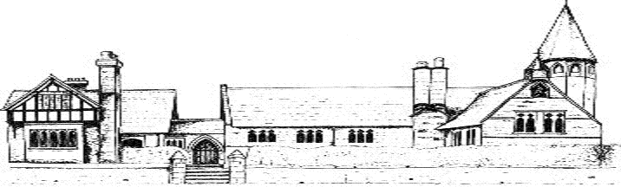
ECCLESTON CE PRIMARY SCHOOL
MUSIC PUPIL VOICE

All children were asked to submit their views on the teaching of Music at Eccleston in the spring terms of 2022. These are our main findings.
- Music is taught weekly
- Children study and listen to a range of composers, musicians and singer songwriters
- Children understand how to get better at music
- Children enjoy the opportunity to learn and play the recorder
- Children enjoy singing together
- Children enjoy the opportunities to compose and to perform

