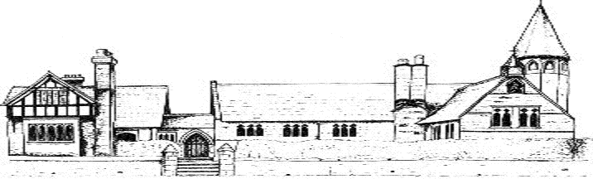
ECCLESTON CE PRIMARY SCHOOL
FIRST AID CURRICULUM

Rabbit Class | How to make an emergency phone call
Squirrel Class | Bites and stings
Badger Class | Asthma  Bleeding
Foxes Class | Choking  Basic Life Support

