`

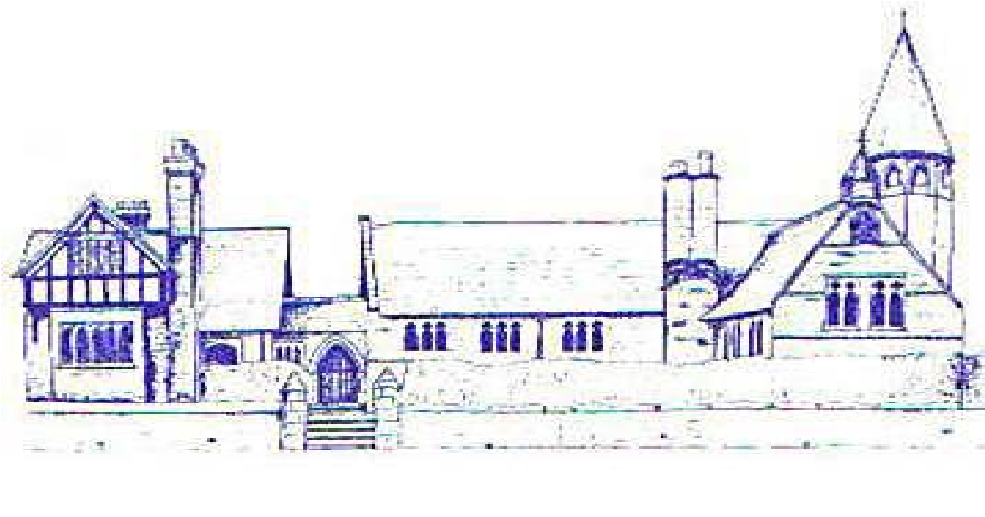

Eccleston C.E. Primary School

Let Our Light Shine

Early Years Foundation Stage
Policy

Curriculum Committee

Reviewed: Spring 2022

Approved by Curriculum Committee: Spring 2022

Approved by Full Governing Board: Spring 2022

Signed by Chair of Governors:

Review Date: Spring 2025

ECCLESTON C.E. PRIMARY SCHOOL

Early Years Foundation Stage Policy

‘Every child deserves the best possible start in life and the support that enables them to fulfil their potential. Children develop quickly in the early years and a child’s experiences between birth and age five has a major impact on their future life chances. A secure, safe and happy childhood is important in its own right. Good parenting and high quality early learning together provide the foundation children need to make the most of their abilities and talents as they grow up.’

Statutory Framework for the Early Years Foundation Stage (DfE 2020)

AIMS

Children who are in our Reception class are in the last year of The Early Years Foundation Stage (EYFS). We aim to ensure children learn and develop well and are kept healthy and safe. We aim to give children a broad range of knowledge and skills that provide the right foundation for good future progress through school and life.

CURRICULUM

In line with the statutory guidance for the EYFS, 2020, we aim to provide:

- quality and consistency in all early year’s settings, so that every child makes good progress and no child gets left behind.
- a secure foundation through learning and development opportunities which are planned around the needs and interests of each individual child and are assessed and reviewed regularly.
- partnership working between practitioners and with parents and/or carers; and
- equality of opportunity and anti-discriminatory practice, ensuring that every child is included and supported.

We recognise that all children are unique and learn in different ways and at different rates. We aim to provide a stimulating environment for our children to learn which includes free access to the indoor and outdoor areas of the classroom. Play underpins our delivery of the EYFS.

There are seven areas of learning and development which are all important and inter-connected.

Prime Areas
Communication and language
Physical development
Personal, social and emotional development.

Specific areas
Literacy.
Mathematics.
Understanding the world; and
Expressive arts and design.

We provide opportunities to promote learning in all seven areas through child-initiated and adult-led purposeful play. Staff respond to children’s interests and needs and provide challenges to ensure children are making progress and developing independent skills to explore the world and solve problems. Our planning takes account of the three characteristics of effective teaching and learning:

- playing and exploring
- active learning
- creating and thinking critically

Every child is assigned a key person who the child is able to build up a special relationship with. Although the class teacher may not necessarily be the assigned key person, she is committed to support children and work in partnership with all families.

All staff at school are committed to ensuring that all children are happy, safe and secure.

Every Reception child has a buddy from Year 5 or 6. Older pupils are encouraged to look after younger pupils and support staff during less structured times of the day.

PLANNING

- Planning reflects the requirements of the EYFS curriculum and is informed by observations and previous learning. Objectives are taken from the EYFS Development Matters document. This states 17 Early Learning Goals (ELGs) which Reception children work towards throughout the year. Planning is flexible and is constantly monitored to meet individual needs of children. A broad long-term plan is produced, and links are made to Year 1 teaching where possible (as children are taught in a mixed year group class). However, plans are flexible, and staff adapt them to respond to children’s needs and interests. Ongoing observational assessments inform weekly planning. Learning objectives, activities, differentiation and deployment of adults and resources are reviewed daily. Both the teacher and teaching assistants lead activities and enhance play through playing with the children by providing additional resources or asking challenging questions. Staff also make observations of children and assess what next steps need to be put in place. Planning allows opportunity for a balance of child initiated activity and adult led activity and play is an integral part of the planned activities.

ASSESSMENT

Children are assessed on entry (base-line assessment). The base-line information is used in conjunction with profiles sent on from pre-schools (if applicable) to inform planning. Observations are used to assess children’s development and interests. Learning Journeys record some aspects of learning but emphasis is placed on adults being with the children to support and challenge rather than in recording evidence. Staff knowledge of where the children are along with practical activities forms the basis for assessing the children.

At the end of Reception, children are assessed against the ELGs. Parents will be informed of where their children are meeting the expected levels of development, exceeding them or emerging towards that level. This will also be used by staff to inform planning for Year 1.

A profile report, together with a short commentary on each child’s skills and abilities in relation to the three key characteristics of effective learning, will be given to parents at the end of the year. This is a written report.

Welfare
It is important to us that all children in the school are ‘safe’. We provide children with choices and allow them to take risks whilst also ensuring they recognise and avoid hazards. We aim to protect the physical and psychological well-being of all children.

“Children learn best when they are healthy, safe and secure, when their individual needs are met and when they have positive relationships with the adults caring for them.”

In line with the Statutory Framework for Early Years Foundation Stage 2021, we:
- promote the welfare and safeguarding of children;
- promote good health, preventing the spread of infection and taking appropriate action when children are ill;
- manage behaviour effectively in a manner appropriate for the children’s stage of development and individual needs;
- ensure all adults who look after the children or who have unsupervised access to them are suitable to do so.
- ensure that the premises, furniture and equipment is safe and suitable for purpose;
- ensure that every child receives enjoyable and challenging learning and development experiences tailored to meet their needs; and
- maintain records, policies and procedures required for safe efficient management of the setting and to meet the needs of the children.

LIAISON WITH PRE-SCHOOL SETTINGS AND INDUCTION

We have close links with local nurseries. Staff liaise about prospective and current pupils and nursery staff provide school with profile tracking documents.
During the summer term, staff visit settings of children due to start in September’s Reception. Families are invited to look around the school during the working school day.
In the summer term, parents are offered the opportunity of a home visit and are invited to attend an information evening. Information booklets are also provided.
Children are invited to spend two half-day sessions at school in the Summer term. A carefully planned, staggered induction period then takes place in September.

School and feeder nurseries work together to ensure a smooth transition to school and there are several opportunities where we work together during the year.

TRANSITION TO YEAR 1

Children are taught in a mixed Reception and Year 1 class which allows for a gentle and easy transition.

Reception staff plan for more structured activities to be undertaken during the summer term as appropriate.

The Autumn Term allows for a smooth transition to more formal learning. Learning in Year 1 is still taught through play-based activities.

HOME/SCHOOL LINKS

The class teacher is available to talk to parents before and after school every day. Parents may make appointments to meet with staff if they wish to discuss anything more formally.

Parent information evenings are held to support transitions and to provide information about curriculum teaching.

Parents use email and informal chat to communicate with the class teacher.

Parents are invited to share significant moments from home. These ‘Wow notes’ are added to children’s Learning Journeys to help form a holistic picture of the child’s first year in school.

A parents evening takes place in the Autumn and Spring term. A written report is given to parents in the Summer term (see ‘Assessment’ above).

EQUAL OPPORTUNITIES AND INCLUSION

Eccleston CE Primary School is committed to providing all pupils with equal access to all aspects of school life regardless of ethnicity, culture, religion, home-language, family background, learning difficulties, disability or gender. All staff aim to act as role models and promote positive attitudes.
We ensure every child is included and supported through equality of opportunity and anti-discriminatory practice. (Statutory Framework for the EYFS 2021)

We believe in early identification of special educational needs and aim to provide additional support for children where necessary and as early as possible. For further information please see the Special Education Needs Policy.

