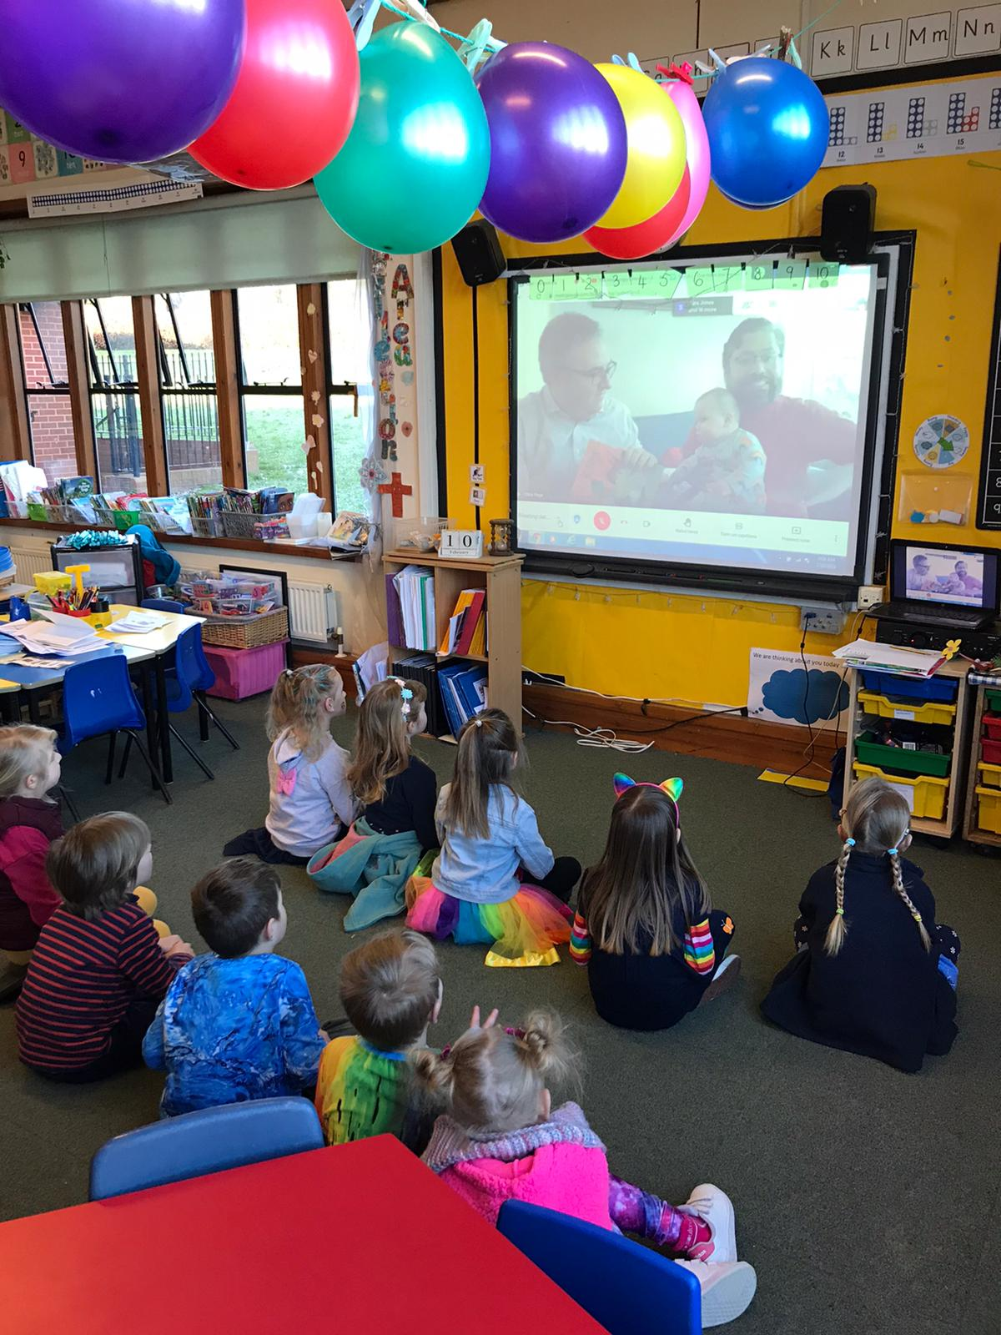

Reception and Year 1 chatted online with a Daddy and a Daddy who have just adopted a baby. They read a lovely book called King and King to us and we asked them questions.

