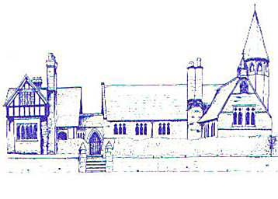

ECCLESTON CE PRIMARY SCHOOL
How our Christian Vision is reflected in our curriculum
Our Vision
At Eccleston CE Primary School, we are united in our vision to prepare our children for life in the modern world. We will do this by instilling a lifelong love of learning and embedding Christian Values which reflect the example Jesus has set.
We strive for excellence in all we do, enabling all members of our school to flourish
"Let your light shine"
-Matthew 5:16
How We Let Our Light Shine in English
- We study texts which promote tolerance and respect
- We study texts written by authors from a range of cultures, thus preparing us for life in modern Britain
- We dramatise texts we study and perform them to an audience, both at school and in our local professional theatre
- We study texts where the protagonists have persisted and succeeded in the face of adversity
How We Let Our Light Shine in Mathematics
- We consider the true value of money and explore whether it is material objects which will help us shine our light
- We attend extraordinary days for gifted mathematicians
- We raise money for charity and count it and sort it
- The Year 6 £10 project allows us to collaborate together to make a profit which we donate to charity

How We Let Our Light Shine in Religious Education
- We learn about agents of change and how to be an agent of change
- We learn about people from other religions and culture and how they let their light shine
- We learn how to be a tolerant and respectful citizen and how to let others shine their light as well as our own
- We have opportunities to discuss and debate important issues with our classmates
How We Let Our Light Shine in Science
- We help others to let their light shine through collaborative work and cooperation
- Practical work allows all to shine, regardless of writing skills
How We Let Our Light Shine in Geography
- We give pupils a voice through which they can address issues such as climate change and pollution
- We learn about environmental changes and how we can make a difference
How We Let Our Light Shine in History
- We learn about and from courageous advocates throughout history
- We learn how we can look at mistakes made in history to make the world a better place
- We study significant people in history who have persisted and succeeded in the face of adversity
How We Let Our Light Shine in PHSE
- We learn about how individual and important we are
- We learn about keeping ourselves and others safe and healthy
- We learn how to foster friendships
- We learn how to tackle bullying

How We Let Our Light Shine in PE
- Through representing our school in team or individual events
- Everyone is encouraged to shine regardless of ability
- We learn how to push ourselves to our limits
- We learn how to cope with failure
How We Let Our Light Shine in Music
- Through performance opportunities in school, in our village and nationally
- By studying ten weeks of instrumental tuition through the First Access Programme
- By providing a weekly Performing Arts Club
- We study a range of music and composers, thus preparing us to shine our light in modern Britain
- We study musicians who have persisted and succeeded in the face of adversity
How We Let Our Light Shine in Computing
- We learn how to keep ourselves safe online
- We learn how to deal with online bullying
How We Let Our Light Shine in Art
- We take pride in our work and everyone’s is displayed around school
- We enter competitions and exhibitions
- We study a range of art and artists, thus preparing us to let our light shine in modern Britain

