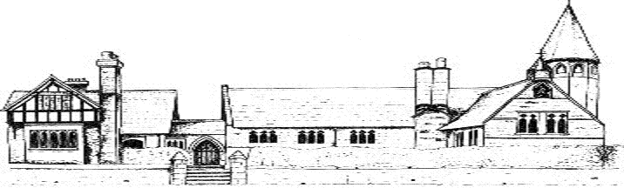

ECCLESTON CE PRIMARY SCHOOL
Let Your Light Shine
Religious Education Curriculum Statement
At Eccleston CE Primary School, we are united in our vision to prepare our children for life in the modern world. We will do this by instilling a lifelong love of learning and embedding Christian values that reflect the example Jesus has set. We strive for excellence in all we do, enabling all members of our school to flourish.
“Let your light shine”-Matthew 5.16

RELIGIOUS EDUCATION AT ECCLESTON CE PRIMARY SCHOOL
Intent
At Eccleston CE Primary School, Religious Education is taught in line with the Diocese of Chester scheme of work, Questful RE and the quality resource Understanding Christianity. We aim to provide a sequential and broad understanding of Christianity as a diverse, global, living faith and to explore the faith of others with a deep respect. In RE we explore faith, encounter faith and engage with questions of meaning and wisdom, expressing our own beliefs. We aim to inform, challenge and celebrate.
Implementation
RE has a high profile within our school and is taught weekly as required by the statement of entitlement.
We currently follow both the Chester Diocesan Scheme of Work and the quality resource Understanding Christianity but are in the process this academic year of changing over to the Blackburn Diocese of Education’s Questful RE. Both our old and new curriculums has been carefully mapped out ensuring coverage of Christianity and other religions as well as the opportunity for children to engage in Big Questions and enter focussed discussions and explorations. We have developed a large and varied collection of artefacts and resources to support the delivery of our curriculum.
RE is taught creatively and practically wherever possible and we also engage in whole school RE days where we will spend the day exploring concepts such as Ascension, Creation or the Trinity. We work closely with our local church and invite people from the church and from other faiths into school wherever possible to enhance learning.
Impact
Our children are tolerant and responsible citizens and leave primary education with a secure understanding of Christianity, other faiths and humanism. Children celebrate diversity locally, nationally and globally and promote positive images of the beliefs, traditions and culture of others. Our RE curriculum ensures that children develop spiritually, academically, emotionally and morally to promote and realise a better understanding of themselves and others and to equip with the opportunities, challenges and responsibilities of living in a rapidly changing, multicultural world.
Religious Education in the Early Years
Children in the Early Years learn to develop a positive sense of themselves and others, and learn how to form positive and respectful relationships. They do this by encountering religious and non-religious worldwide views through special people, books, places and objects and by visiting our local church. They listen to and enjoy stories from other religions and are introduced to specific vocabulary.

