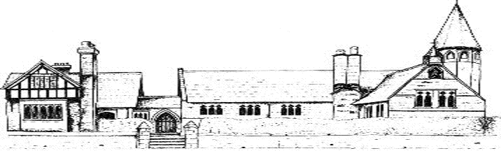

ECCLESTON CE PRIMARY SCHOOL
Let Your Light Shine
Writing Curriculum Statement
At Eccleston CE Primary School, we are united in our vision to prepare our children for life in the modern world. We will do this by instilling a lifelong love of learning and embedding Christian values that reflect the example Jesus has set. We strive for excellence in all we do, enabling all members of our school to flourish.
“Let your light shine”-Matthew 5.16

WRITING AT ECCLESTON CE PRIMARY SCHOOL
Intent
At Eccleston CE Primary School, we believe that all pupils should be able to confidently communicate their knowledge, ideas and emotions through writing. We want our pupils to enjoy a wide vocabulary, a good understanding of grammar and to be able to spell new words by applying taught patterns and rules. We want our children to be able to write clearly, accurately and coherently, adapting their language and style in and for a range of contexts, purposes and audiences. We believe that all our pupils should be encouraged to take real pride in the presentation of their writing and encourage a joined style by the time they leave in year 6. We want our writers to be confident in refining and editing their writing over time, identifying their own areas for improvement during the writing process.
Implementation
All our children are exposed to progressive, high quality texts across a range of genres. We use imaginative and creative lessons in order to ignite children’s passion for writing throughout a range of teaching styles such as drama, role play and classroom discussion. We use two quality programmes (Steps to Read and Read to Write) both of which have a progressive, sequential approach using high quality and engaging texts.
In Key Stage 1 and Early Years, we place great importance on the teaching of phonics. During the daily lesson, children will revisit previous learning, learn new skills, practise and apply their knowledge in an engaging and stimulating environment. Teachers provide opportunities for these skills to be used in writing across the curriculum.
All our children have daily opportunities to read a variety of books in school, including regularly with an adult. Each classroom has a class library and all children can access this throughout the day. We also have a school library which each class visits regularly.
Spelling rules and patterns and taught thoroughly and the children are assessed on the spelling of the identified words in the National Curriculum.
Grammar and Punctuation and taught both discreetly and explicitly. Wherever possible, we link these lessons to our quality texts.
Impact
As a result of our curriculum and our constant push for reading for pleasure, our school is full of enthusiastic readers and writers who are confident when showcasing their skills. Our assessment results, both school based and nationally, are generally above average.
Writing in the Early Years
At Eccleston CE Primary School, we promote early writing at every opportunity, through phonics lessons, across the curriculum and through our continuous provision.
In Reception, we begin to teach individual phonemes for both reading and writing during our daily phonics session. In addition, we share a love of reading with high quality texts and traditional stories and rhymes.

