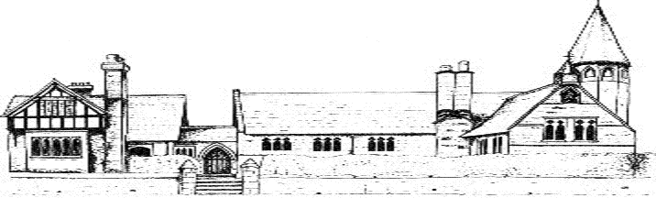

ECCLESTON C.E. PRIMARY SCHOOL
PHYSICAL EDUCATION END POINTS AND
KNOWLEDGE

By the end of Year 1, our children will;
Skills
Gymnastics movements | - Be able to make their bodies curled, tense, stretched and relaxed  - Roll, curl, travel and balance in different ways  - Be able to control their bodies when travelling and balancing  - Copy sequences and repeat them
Basic movements and team games | - Be able to throw underarm  - Be able to throw and kick in different ways  - Be able to catch and bounce a ball  - Be able to run at different speeds
Dance | - Perform their own dance moves  - Be able to react appropriately to music  - Copy or make up a short dance  - Move safely in a space  - Have had opportunities to perform to their class and parents
Knowledge
Health and Fitness | - Be able to describe how the body feels before, during and after exercise  - Carry and place equipment safely  - Understand that exercise is important to fitness
Sportspersonship | - Have some understanding of the importance of being a ‘good loser’
Vocabulary
Balance, underarm, fitness, attacking, defending, improvement

By the end of Year 3, our children will;
Skills
Gymnastics movements | - Plan and perform a sequence of movements  - Improve a sequence based on feedback  - Adapt sequences to suit different types of apparatus and criteria  - Compare and contrast gymnastics sequences  - Be able to develop the quality of their movement  - Be able to watch, describe and evaluate the effectiveness of a performance
Athletics | - Be able to run at fast, medium and slow speeds, changing speed and direction  - Be able to take part in a relay
Dance | - Be able to improvise freely, translating ideas from an idea to a movement  - Be able to share and create phrases with a partner and a small group  - Be able to repeat remembered dance phrases  - Understand how different types of music affect dance skills and traditions  - Be able to develop the quality of their movement  - Be able to watch, describe and evaluate the effectiveness of a performance
Games | - Be aware of space and how to use it appropriately to support team mates as well as to cause problems for the opposing team  - Be able to throw and catch with increasing accuracy and in different ways  - Be able to bounce and kick a ball whilst moving  - Be able to use kicking and dribbling skills in a game  - Be able to pass the ball in different ways  - Understand and begin to apply the basic principles of invasion games  - Know how to play a striking and fielding game fairly
Knowledge
Health and Fitness | - Be able to explain how strength and suppleness affect performance  - Understand the importance of strength and flexibility  - Know why it is important to warm up and cool down
Sportspersonship | - Understand the importance of rules in games  - Apply and follow rules fairly  - Be able to compete against others in a controlled manner
Vocabulary
sequence, team player, control, coordination, striking, fielding

By the end of Year 5, our children will;
Skills
Gymnastics movements | - Be able to move in a controlled way  - Be able to include changes to speed and direction in a sequence  - Work collaboratively with a partner to create, repeat and improve a more complicated sequence  - Be able to combine action, balance and shape
Athletics | - Be able to spring over a short distance and show stamina when running over longer distances  - Be able to jump and throw in different ways  - Show control when taking off and landing  - Be able to combine running and jumping
Dance | - Be able to compose their own creative dances  - Be able to evaluate the performances of themselves and others  - Be able to perform dance which shows clarity, fluency, accuracy and consistency  - Be able to use dance to communicate an idea
Games | - Be able to choose the best tactics of attacking and defending  - Be able to devise and adapt rules to create their own games  - Be able to perform and apply skills and techniques effectively and accurately  - Be able to keep and win back possession of the ball  - Demonstrate an increasing awareness of space
Knowledge
Health and Fitness | - Be able to explain why exercise is good for your health  - Be able to explain some safety principles when preparing for and during exercise
Sportspersonship | - Understand the importance of being a team player
Vocabulary
opposition, Sportspersonship,

By the end of Year 6, our children will;
Skills
Gymnastics movements | - Be able to combine their own work with that of others  - Be able to create sequences to specific timings  - Be able to choose their own style and music to perform to
Athletics | - Demonstrate stamina and increasing strength  - Have participated in a range of athletics activities such as relay, hurdles, sprint
Dance | - Be able to combine their own work with that of others  - Be able to create sequences to specific timings  - Be able to choose their own style and music to perform to
Games | - Be able to use different techniques for throwing and catching  - Understand how to play a range of games such as football, softball, tennis, netball and rugby  - Be able to follow and create complicated rules to play a game successfully
Knowledge
Health and Fitness | - Understand how to use exercise for a healthy life beyond primary school  - Know ways they can become healthier
Sportsmanship | - Be able to agree and explain rules to others  - Be able to work as a team and communicate ideas  - Be able to lead others as appropriate and be led
Vocabulary
technique, backhand, evaluate

