ECCLESTON CE PRIMARY SCHOOL
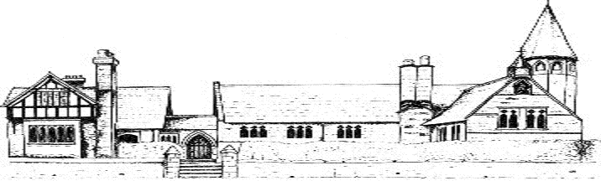
GEOGRAPHY CURRICULUM
CYCLE A
 | Autumn | Spring | Summer
Class 1 | Physical and human geographical features of the local area. Simple fieldwork and map work of Eccleston and Chester | Seasonal and daily weather patterns in the United Kingdom focusing on children’s own experience of weather | Geographical similarities and differences through studying the physical or human geography of country and local area
Class 2 | Comparing Chester with a similar sized area in a non-European country. Continents and capital cities | Weather and climate | Fieldwork/map skills
Class 3 | Local knowledge  World countries | Human and physical geography | Geographical skills and fieldwork
Class 4 | Locational knowledge – Antarctica physical and human | Mapping World War 2 Investigating countries involved in World War 2 | (Mexico) Fieldwork

CYCLE B
 | Autumn | Spring | Summer
Class 1 | Physical and human geographical features of the local area. Simple fieldwork and map work of Eccleston and Chester | Seasonal and daily weather patterns in the United Kingdom focusing on children’s own experience of weather | Geographical similarities and differences through studying the physical or human geography of country and local area
Class 2 | Physical geography of UK, locational knowledge, compare Isle of Coll. | Map skills – comparing maps and photos from past and present | Fieldwork – local environment, habitats
Class 3 | Local knowledge  World countries | Human and physical geography | Geographical skills and fieldwork
Class 4 | Locational knowledge – Antarctica physical and human | Mapping World War 2 Investigating countries involved in World War 2 | (Mexico) Fieldwork

