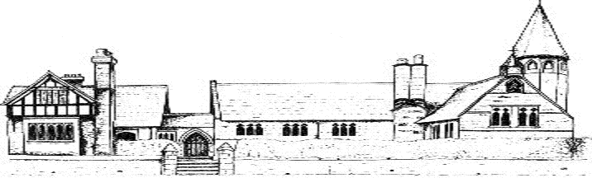

ECCLESTON CE PRIMARY SCHOOL
Let Your Light Shine
Physical Education Curriculum Statement
At Eccleston CE Primary School, we are united in our vision to prepare our children for life in the modern world. We will do this by instilling a lifelong love of learning and embedding Christian values that reflect the example Jesus has set. We strive for excellence in all we do, enabling all members of our school to flourish.
“Let your light shine”-Matthew 5.16

PHYSICAL EDUCATION AT ECCLESTON CE PRIMARY SCHOOL
Intent
Through the teaching of Physical Education at Eccleston CE Primary School and the range of extra curriculum activities that we offer, we aim to develop the children’s processes of collaboration, co-ordination, spatial awareness, physical skill, fitness and general well-being. We want out children to make informed choices about physical activity throughout their lives and to promote positive attitudes towards hygiene, fitness, health and well-being.

Implementation
We use the aims of the National Curriculum to ensure all children;
- Develop competence to excel in a broad range of physical activities
- Are physically active for sustained periods of time
- Engage in competitive sports and activities and lead healthy, active lives
We use specialist PE coaches to deliver at least one lesson a week per class. This provision is monitored regularly by our provider and by the SLT. We also provide a range of after school activities such as football, multi-sports, gymnastics, dance, athletics and fencing. We also use yoga throughout school to support physical development and positive mental health. We also participate in the Daily Mile.
We hold a sports afternoon annually and encourage children to compete against others in the areas of football and cross country.
Our playground equipment is under constant review and an improvement programme in order to provide the best we can for our children.
Impact
Our children are encouraged to be active and healthy and to start to take some responsibility for their own fitness and well-being. Opportunities to compete in sport build character and help to embed importance values such as fairness and respect.

Physical Education in the Early Years
Children are encouraged to focus on different ways of moving and on their balance. Co-ordination is developed as is control in both small and large movements. Ball skills are introduced and children understand the importance of exercise for their own health.

