ECCLESTON CE PRIMARY SCHOOL
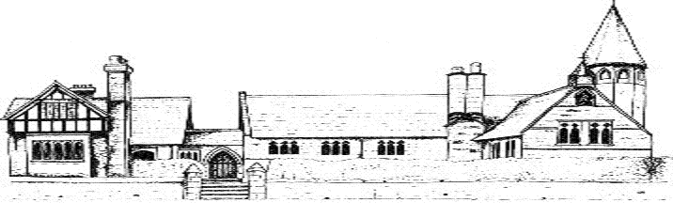
PHSE CURRICULUM

We follow the Jigsaw Programme for PHSE which is copyrighted, therefore we are unable to publish details. Paper copies are available from school. Children also receive a block of lessons on the Kidsafe Programme.
 | Autumn |  | Spring |  | Summer
Class 1 | Being Me In My World | Celebrating Difference | Dreams and Goals | Healthy Me | Relationships | Changing Me
Class 2 | Being Me In My World | Celebrating Difference | Dreams and Goals | Healthy Me | Relationships | Changing Me
Class 3 | Being Me In My World | Celebrating Difference | Dreams and Goals | Healthy Me | Relationships | Changing Me
Class 4 | Being Me In My Wld | Celebrating Difference | Dreams and Goals | Healthy Me | Relationships | Changing Me

