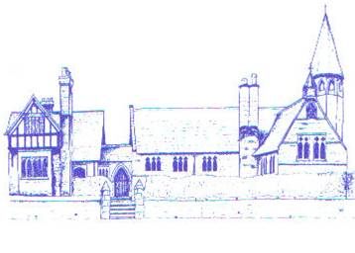

Charity Work at Eccleston CE Primary School

“Give, and it will be given to you. Good measure, pressed down, shaken together, running over, will be put into your lap. For with the measure you use it will be measured back to you.”
-Luke 6:38
Local | National | Global
Cheshire West and Chester Foodbank  Hospice of the Good Shepherd in Chester  Cheshire Downs Syndrome Support Group  Save the Family, Chester  Christmas pyjama donation to disadvantaged children | Comic Relief  Children In Need  British Legion Poppy Appeal  Macmillan Cancer Support  Parkinson’s UK | Sponsorship of a child in Somalia through ActionAid  Comic Relief  Children In Need  Operation Christmas Child  Fairtrade Week  Village Water  Christian Aid

