My Jesus
Majestic, he walks on the water, pools rippling beneath the feet of Our Christ,
Holy, he stands before me, laying fish and bread into my hungry hands.
| bow my head. Darkness.
Carefully, he sinks his hand into my body, my blood,
Into my frozen, crisp heart.
It melts like gentle snowflakes.
I see – a shimmer of light! A miracle!
Awed, I gaze as his love flows through me, lighting my eyes once more.
His gentle words touch my very soul.
His mighty hands heal
And give me hope, love and peace.
I am glowing with the warmth and love of the world.
Of my Jesus.
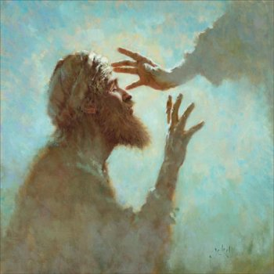

By Years 4 and 5 (Key Stage 2),
Eccleston CE Primary School

